Pseudo 3D Step-By-Step
Started 12/10/2020

When I was at college I took an engineering chemistry class. The professor was a nice guy but couldn't explain anything in class that I could follow along or understand. I think he knew the class was struggling and therefore introduced what was called a "programmed textbook." It followed the class textbook by explaining every minute step. Questions and answers were given on separate pages and every equation was derived in detail. At first I thought I would flunk the class for sure, but with the programmed textbook I easily aced the course and understood engineering chemistry.

Our goal in this tutorial is to make a pseudo 3D outrun-like game. Others have done something similar but if you're like me, following their reasoning and understanding their code is anything but easy or even doable. I hope to do something like a "programmed textbook" by explaining step-by-step how the equations for this technology are derived and how to use them in code to make the game.

Our game consists of a road that the player drives on. The road consists of any number of segments that we put together to form the road. The segments alternate colors and are drawn so they give the illusion that the player is moving down the road.

Step 1: Game Template with Full Screen Option
To make our programming easier we'll use the p5.js library. Point your web browser to https://editor.p5js.org/ to get started. Click on 'Sign up' at the top right and create an account. This will let you download the starter code we create in the editor and save changes to your online project. The initial code the editor gives you creates an html 5 canvas and displays it when you click the run icon ():

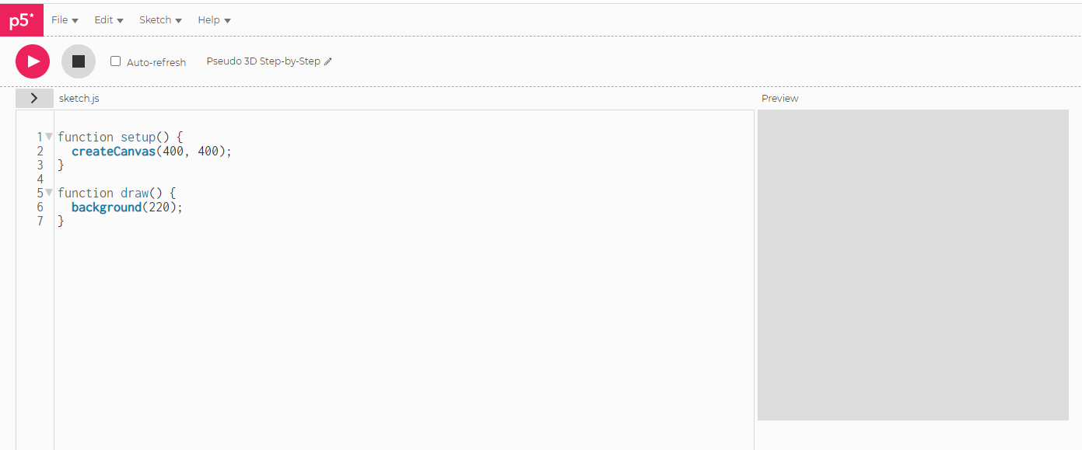

Nice, we have a preview of our game up and running in less than a minute! Click '>' below the run icon so you can see the project files.

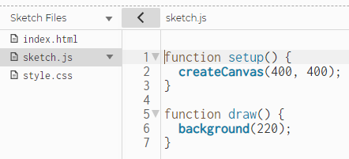
We're going to start with a canvas 640 pixels wide by 400 pixels tall, so change the createCanvas call to reflect that and press the run icon to get:

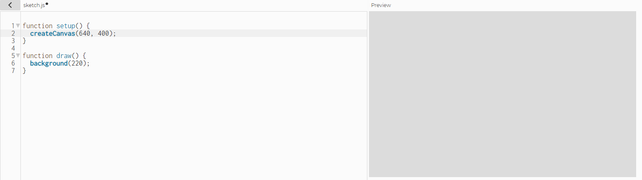

At this point it's a good idea to save your project by selecting File | Save from the editor menu. You may also want to rename your project to something more meaningful than what the editor gave it by clicking the pencil icon near the top left of the editor.

This project will be object oriented so we will create a Game class that contains a Road class that contains multiple Segment classes. First, though we will create a settings file that lets us easily make various settings that the game can read without our needing to change code for modifications. Select Sketch | Add File and add a settings.js file as follows:

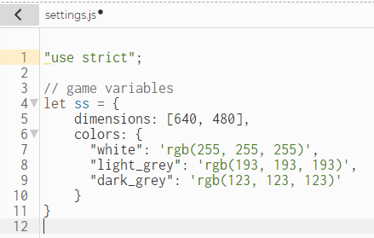

Then select Sketch | Add File again and add a game.js file as follows:

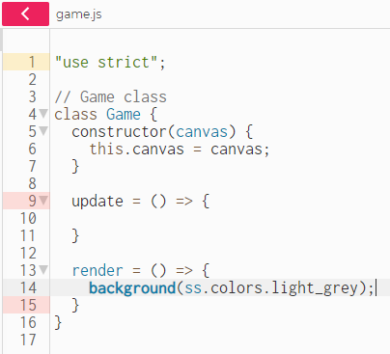

Modify the sketch.js file as follows:

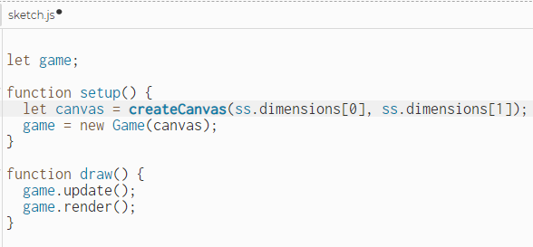

Also make sure your index.html file looks like this with the addition of the two ".js" files near the bottom:

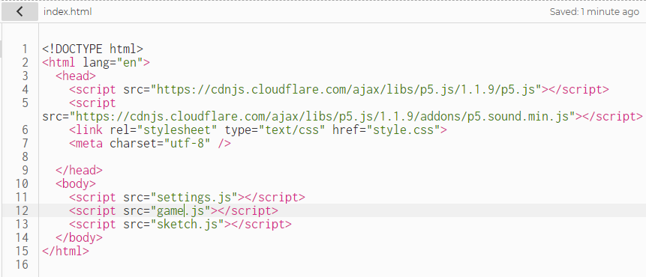

Click the run button and you should see a preview of the light-grey canvas.
To add a little flair to our game we're going to allow the user to run it in fullscreen mode. To do this, click Sketch | Add File and add the file helpers.js that looks like this:

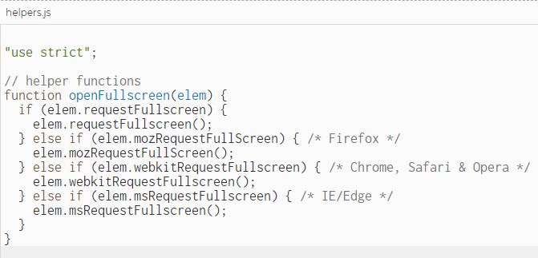

Make sure you add helpers.js to the index.html file:

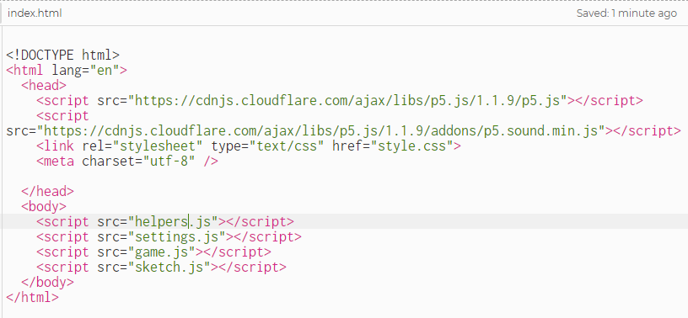

Also modify sketch.js to look like this:

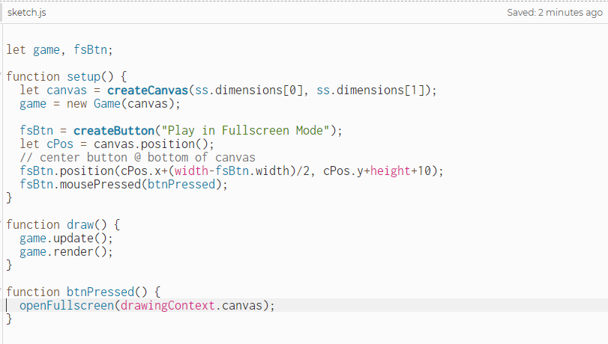

The p5.js online editor is great for getting started but fairly limited beyond that. We're going to switch over to Microsoft Visual Studio Code at this point which will give us intellisense, code complete and many more conveniences. From the p5.js online editor select File | Save then File | Download. p5's online editor will save a zip file to your hard disk. Create a folder on your hard drive named 'Pseudo3DStepByStep' and unzip the saved file into it.
If you don't have Visual Studio Code installed on your computer, either google it & install it or go here to download the installation file: https://code.visualstudio.com/. After installing it, select File | Open Folder… and select the 'Pseudo3DStepByStep' folder where you unzipped the ps5.js editor files. Now load index.html and delete the line '<script src="p5.sound.min.js"></script>'. Save index.html back to disk and double-click it. It should display the following:

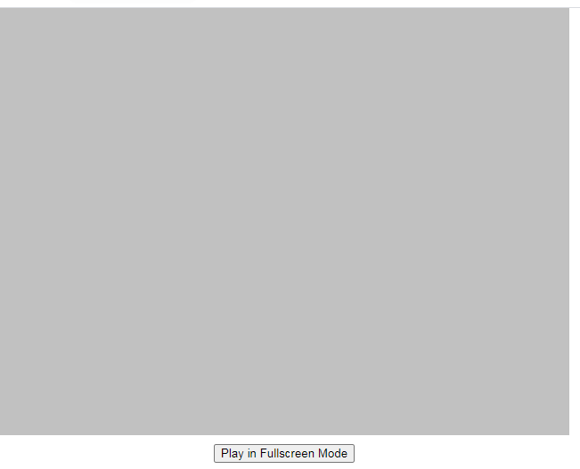
When you click the button at the bottom it should display fullscreen mode. You can exit fullscreen by pressing the Esc key. This works fine but we want our directory structure to be a little more organized. Create three directories named 'css', 'js', and 'libraries' in the 'Pseudo3DStepByStep' folder. Then move the file style.css to the css folder; move the files game.js, helpers.js, settings.js and sketch.js to the js folder; and then move the files p5.js and p5.sound.min.js to the libraries folder.
Visual Studio Code editor should automatically show the changes to your directory structure, but if it doesn't just select File | Open Folder… and select the 'Pseudo3DStepByStep' folder. Now rename index.html to Pseudo3DStepByStep.html, load it into Visual Studio Code and modify it to show as follows:

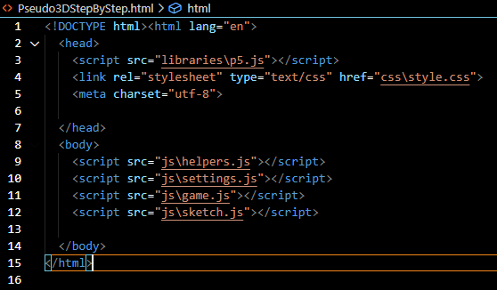
In Windows Explorer double-click Pseudo3DStepByStep.html to verify it works.

You can download the complete source code for Step 1 from:
https://github.com/cewareham/Pseudo-3D-Step-by-Step/tree/5d58f421d573f699119fc3c9a2c7606258b84611
Go there, select the Code button and then Download ZIP. Unzip the files to any directory and double-click Pseudo3DStepByStep.html to verify it works.

Step 2: A Basic 2D Road

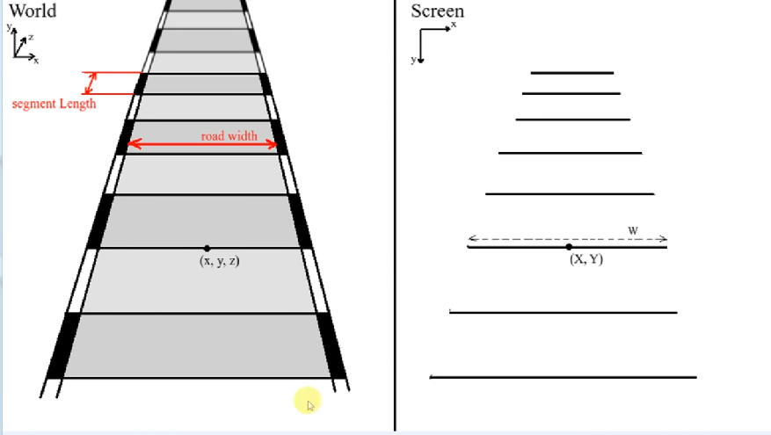

Ultimately, we want to take 3D world coordinates (x, y, z) and project them onto our 2D monitor so they look 3D. Before we go into the complexities of 3D we'll do our road in 2D so we understand the road geometry. Notice on the left side of the above figure we have a road width and segment length; we'll specify both of these in pixels. Also notice that each segment has a top and bottom line. Knowing the coordinates of the top and bottom line of each segment gives us 4 points to draw a polygon that represents that segment.
On the right side notice the coordinates X, Y and W. The coordinates (X, Y) are at the center of a segment line and W is the width of the segment line (top or bottom). Knowing these values allows us to calculate the 4 points of each segment polygon. A segment line has the coordinates:
( xLeft, yLeft) = (X-W/2, Y)
(xRight, yRight) = (X+W/2, Y)
Each segment has a top and bottom line for which we calculate these coordinates.

